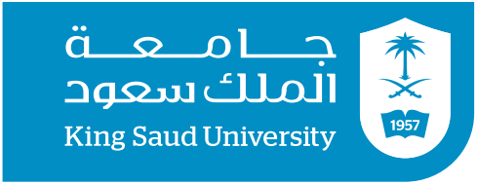

CBA Program course plan Guide: Management (HR Management Track)
The following is the course plan that should be followed for the above program. Please check the required course that you intend on taking for the stated semester and arrange to discuss with your academic advisor when having questions about registering for course in different order.

Top of Form
Fifth semester |  | Sixth semester
102 BUS HR Management (PR/101BUS) |  | 210 BUS Legal Environment of Business
103 ARAB Expository Writing |  | 301 MKT Consumer Behavior (PR/201MKT)
121 BUS Organizational Behavior (PR/101BUS) |  | 413 BUS Managerial Leadership (PR/121BUS)
211 BUS Research Methodology (PR/107QUA) |  | Elective…………………………………………………………………
214 BUS Bus. Ethics & Social Responsibility (PR/101BUS) |  | Elective…………………………………………………………………
Elective………………………………………………………………… |  | Elective…………………………………………………………………
Seventh semester |  | Eighth semester
361 BUS HR Training & Development (PR/102BUS) |  | 241 BUS HR Planning & Staffing (PR/102BUS)
371 BUS Operations Man. (PR/101BUS) |  | 411 BUS Strategic Man. (PR/101BUS-200FIN-201MKT)
425 BUS Org. Change & Development |  | 461 BUS Compensation Management (PR/102BUS)
462 BUS Performance Management (PR/102BUS) |  | Elective…………………………………………………………………
Elective………………………………………………………………… |  | Elective…………………………………………………………………

Electives | Islamic Studies (8) | Electives from MGMT Dept. (6) | Electives from other Dept. (9)
 | 100 IC Studies in Prophet Biography | 251 BUS Knowledge Management (PR/101BUS) | 101 SOC Principles of Sociology
 | 101 IC Principles of Islamic Culture | 301 BUS International HR Management (PR/102BUS) | 307 QUA Business Forecasting
 | 102 IC Family in Islam | 318 BUS Quality Management (PR/101BUS) | 323 PSY Theories of Learning
 | 103 IC Economic System in Islam | 330 BUS Managerial Skills (PR/101BUS) | 379 PSY Psychological Counseling in Occpl. Field
 | 104 IC Islamic Political System | 416 BUS Strategic HR Management (PR/102BUS) | 421 ECON Feasibility Studies & Project Evaluation (PR/102ECON-200FIN-201MKT)
 | 105 IC Human Rights | 418 BUS Health & Occupational Safety | 452 MKT Services Marketing (PR/201MKT)
 | 106 IC Medical Jurisprudence | 427 BUS Corporate Governance
 | 107 IC Professional Ethics
 | 108 IC Current Issues
 | 109 IC Development Role of Women

Proposed Schedule for Academic Year/Semester:…………………………
Student Name:…….………………….……………………
Student ID:…………………………………………………..
Academic Advisor:……………………………………….
Signature:…………………………………………………….

