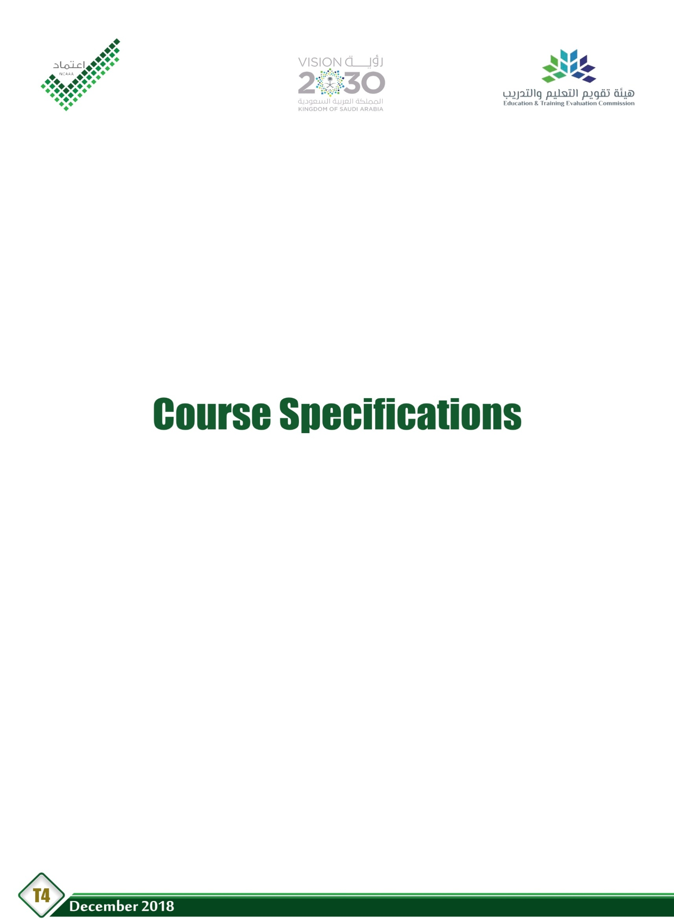

Course Title:
Course Code:
Program:
Department:
College:
Institution:

Table of Contents
A. Course Identification 3
6. Mode of Instruction (mark all that apply) 3
B. Course Objectives and Learning Outcomes 3
1. Course Description 3
2. Course Main Objective 3
3. Course Learning Outcomes 4
C. Course Content 4
D. Teaching and Assessment 4
1. Alignment of Course Learning Outcomes with Teaching Strategies and Assessment Methods 4
2. Assessment Tasks for Students 5
E. Student Academic Counseling and Support 5
F. Learning Resources and Facilities 5
1.Learning Resources 5
2. Facilities Required 5
G. Course Quality Evaluation 6
H. Specification Approval Data 6

A. Course Identification

1. Credit hours:
2. Course type
a. | University |  |  |  | College |  |  |  | Department |  |  |  |  | Others
b. |  | Required |  |  |  |  | Elective
3. Level/year at which this course is offered:
4. Pre-requisites for this course (if any):

5. Co-requisites for this course (if any):

6. Mode of Instruction (mark all that apply)
No | Mode of Instruction | Contact Hours | Percentage
1 | Traditional classroom
2 | Blended
3 | E-learning
4 | Correspondence
5 | Other

7. Actual Learning Hours (based on academic semester)
No | Activity | Learning Hours
Contact Hours
1 | Lecture
2 | Laboratory/Studio
3 | Tutorial
4 | Others (specify)
 | Total
Other Learning Hours*
1 | Study
2 | Assignments
3 | Library
4 | Projects/Research Essays/Theses
5 | Others(specify)
 | Total
*The length of time that a learner takes to complete learning activities that lead to achievement of course learning outcomes, such as study time, homework assignments, projects, preparing presentations, library times

B. Course Objectives and Learning Outcomes

1. Course Description

2. Course MainObjective

3. Course Learning Outcomes
CLOs |  | AlignedPLOs
1 | Knowledge:
1.1
1.2
1.3
1...
2 | Skills :
2.1
2.2
2.3
2...
3 | Competence:
3.1
3.2
3.3
3...

C. Course Content
No | List of Topics | Contact Hours
1
2
3
4
5
...
Total

D. Teaching and Assessment

1. Alignment of Course Learning Outcomes with Teaching Strategies and Assessment Methods
Code | Course Learning Outcomes | TeachingStrategies | AssessmentMethods
1.0 | Knowledge
1.1
1.2
…
2.0 | Skills
2.1
2.2
…
3.0 | Competence
3.1
3.2
…

2. Assessment Tasks for Students
# | Assessment task* | Week Due | Percentage of Total Assessment Score
1
2
3
4
5
6
7
8
*Assessment task (i.e., written test, oral test, oral presentation, group project, essay, etc.)

E. Student Academic Counseling and Support
Arrangements for availability of faculty and teaching staff for individual student consultations and academic advice :

F. Learning Resources and Facilities

1.Learning Resources
Required Textbooks
Essential References Materials
Electronic Materials
Other Learning Materials

2. Facilities Required
Item | Resources
Accommodation
(Classrooms, laboratories, demonstration rooms/labs, etc.)
Technology Resources
(AV, data show, Smart Board, software, etc.)
Other Resources
(Specify, e.g. if specific laboratory equipment is required, list requirements or attach a list)

G. Course Quality Evaluation
Evaluation  Areas/Issues | Evaluators | Evaluation Methods
Evaluation areas (e.g., Effectiveness of teaching and assessment, Extent of achievement of course learning outcomes,Quality oflearning resources, etc.)
Evaluators (Students,Faculty, Program Leaders,Peer Reviewer, Others (specify)
Assessment Methods(Direct, Indirect)

H. Specification Approval Data
Council / Committee
Reference No.
Date

